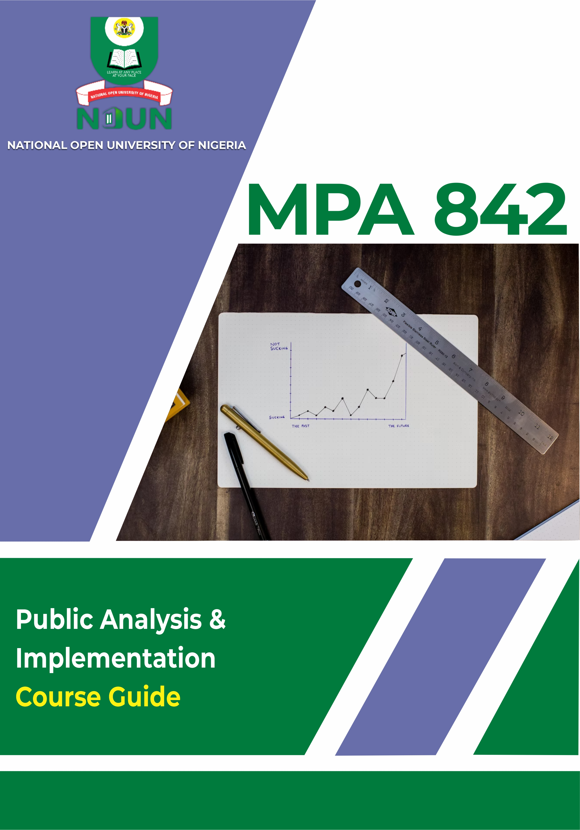

MPA 842 Policy Analysis and Implementation

Course Guide

Course Developer/Writer
Martha Oruku, National Open University of Nigeria
Course Editor
Abdukkahi, Mohammed Yamma, Nasarawa State University

Credits of cover-photo: Mr. Gbenga Aiyejumo, National Open University of Nigeria.

National Open University of Nigeria - 91, Cadastral Zone, Nnamdi Azikiwe Express Way, Jabi, Abuja, Nigeria.



www.nou.edu.ng centralinfo@nou.edu.ng
oer.nou.edu.ng oerunit@noun.edu.ng OER repository
Published in 2021 by the National Open University of Nigeria
© National Open University of Nigeria 2021

This publication is made available in Open Access under the Attribution-ShareAlike4.0 (CC-BY-SA 4.0) license. By using the content of this publication, the users accept to be bound by the terms of use of the Open Educational Resources repository oer.nou.edu.ng of the National Open University of Nigeria.
The designations employed and the presentation of material throughout this publication do not imply the expression of any opinion whatsoever on the part of National Open University of Nigeria concerning the legal status of any country, territory, city or area or of its authorities, or concerning the delimitation of its frontiers or boundaries. The ideas and opinions expressed in this publication are those of the authors; they are not necessarily those of National Open University of Nigeria and do not commit the organization.

How to re-use and attribute this content
Under this license, any user of this textbook or the textbook contents herein must provide proper attribution as follows: “First produced by the National Open University of Nigeria” and include the NOUN Logo and the cover of the publication. The repository has a version of the course available in ODT-format for re-use.
If you use this course material as a bibliographic reference, then you should cite it as follows: “NSC 106: Medical Microbiology and Parasitology, Module 6, National Open University of Nigeria, 2021 at oer.nou.edu.ng
If you redistribute this textbook in a print format, in whole or part, then you must include the information in this section and give on every physical page the following attribution:
Downloaded for free as an Open Educational Resource at oer.nou.edu.ng If you electronically redistribute part of this textbook, in whole or part, then you must retain in every digital file (including but not limited to EPUB, PDF, ODT and HTML) the following attribution:

Downloaded for free from the National Open University of Nigeria (NOUN) Open Educational Resources repository at oer.nou.edu.ng

Introduction
This course is a two credit unit course consisting of 15 units. It is a one-semester, core course for students taking a Masters degree in public administration. Each unit is to be covered in two hours. The course has five modules and 15 units. This course guide gives you an idea of what to expect, as you study this course. Tutor-marked assignments are provided at the end of each unit.

Course Aims
The aim of this curse is to enrich your knowledge on the concept of policy, its features and implementation process. Therefore, you will be exposed to:
- concepts of public policy and policy analysis
- different methods and approaches in policy analysis
- models of policy-making techniques and tools of policy analysis.

Course Objectives
The main objectives of this course are given in each unit. However, at the end of this course, you should be able to:
- explain public policy and policy analysis
- describe models, theories, approaches, tools and techniques of public policy
- highlight problems encountered in policy implementation and evaluation process.

Working Through This Course
To complete this course, you are required to read the study units, read recommended books and read other materials provide by the National Open University of Nigeria (NOUN). Most of the units contain self-assessment exercises; you are required to submit assignments for assessment purposes. At the end of this course, there is a final examination. Stated below, are the components of the course and what you are expected to do.

Course Materials
The major components of the course are:
- Course guide
- Study units
- Textbooks
- Assignment file
- Presentation schedule

Study Units
There are 15 units in this course. They are as follows.
Module 1 Policy Conception and Characteristics
Units 1 The Concept and Field of Public Policy
Unit 2 The Uses and Types of Public Policies
Unit 3 The Prescriptive, Descriptive, Micro and Macro Approaches
Module 2 Methods and Approaches in Policy Analysis
Unit 1 The Dependent and Independent Variables
Unit 2 The Qualitative and Quantitative Approaches
Unit 3 System and Elite Theories
Module 3 Theories of Policy Making
Unit 1 Institutional and Group Theories
Unit 2 Models of Policy Making
Unit 3 The Policy Process
Module 4 Modules of Policy Process
Unit 1 Actors in Policy Analysis
Unit 2 System Analysis, Cost Benefit Analysis and CostEffectiveness
Module 5
Unit 1 Management by Objectives (MBO) and Planning-Programme Budgeting System (PPBS)
Unit 2 Game Theory and Zero-Based Budgeting, Decision Analysis and Decision Tree
Unit 3 Critical Path Method (CPM), Programme Evaluation and Review Technique (PERT) and the Delphi Method
Unit 4 A Case Study of Nigeria’s Industrial Policy
Module one conceptualises policy and its characteristics. Module two analyses methods and approaches in policy analysis, while module three discusses theories of policymaking; and module five explains the tools and techniques in policy analysis.

Textbooks and References
There are also textbooks, listed under the references’ section, and other resources for further reading. They are meant to give you additional information if only you can lay your hands on any of them. You are advised to practice the self-assessment exercises and tutor-marked assignment questions for greater understanding of the course. By so doing, the stated learning objectives of the course will be achieved.

Assignment File
There are two aspects to the assignment of this course. In this file, you will find all the details of the work you must submit to your course facilitator for marking. The marks you obtain for these assignments will count towards the final mark you obtain for this course. There are many assignments for this course, with each unit having at least one assignment. These assignments are basically meant to assist you to understand the course.

Assessment
Your assessments for this course are made up of two components:
- tutor-marked assignment
- final examination.
You should note that the SAEs are not part of your formal assessments but it is important to complete all of them.

Self-Assessment Exercise
Each unit is this course has a TMA attached to it. You can only do the TMA after reading each unit. Normally, the TMAs are kept in a separate file. Your facilitator will mark and comment on it. You should, therefore, pay attention to such feedback from your facilitator and use it to improve your other assignments.
You can write the assignment by using materials from your study units and from textbooks or other sources. However, it is preferable that as graduate students, you should demonstrate evidence of wide reading -something to show that you have researched more widely. You must remember that copying from any source without acknowledgement is plagiarism, and it is not acceptable. References must be properly written, if you use other people’s work. The assignments are, in most cases, easy questions. Examples from your own experience or environment are relevant when you answer such questions. This allows you to apply theory to real life situations.

Final Examination And Grading
At the end of the course, you will write the final examination. It will attract the remaining 70%. This makes the total final score to be 100%.

Course Marking Scheme
Assessment | Marks
Assignments | Best three marks of the assignments @  10% each (on the average) = 30% of course marks
Final examination | 70% of overall course marks.
Total | 100% of course marks

How To Get The Most From This Course
In distance learning, the study units replace the lecturer. There is the advantage of reading and working through the course material at the pace that suits the learner best. You are advised to think of it as reading the lecture as against listening to the lecturer. The study units provide exercises for you to do at appropriate periods instead of receiving exercises in the class.
Each unit has common features which are designed, purposely, to facilitate your reading. The first feature being an introduction to the unit, the manner in which each unit is integrated with other units and the entire course. The second feature is a set of learning objectives. These objectives should guide your study. After completing the unit, you should go back and check whether you have achieved the objectives or not. The next feature is self- assessment exercises, study questions which are found throughout each unit. The exercises are designed basically to help you recall what you have studied and to assess your learning by yourself. You should do each self-assessment exercise and the study question as you come to each in the study unit. The next features are conclusion and summary at the end of each unit. These help you to recall all the main topics discussed in the main content of each unit. There are also tutor-marked assignments at the end of appropriate units. Working on these questions will help you to achieve the objectives of the unit and to prepare for the assignments which you will submit and the final examination.
It should take you above one hour-thereabouts, to complete a study unit, including the exercises and assignments. Upon completion of the first unit, you are advised to note the length of time it took you, and then use this information to draw up a timetable to guide your study of the remaining units. The margins on either sides of each page are meant for you to make notes on main ideas or key points for your usage when revising the course. These features are for your usage to significantly increase your chances of passing the course.

Facilitators/Tutors And Tutorials
There are many ways of learning as an open distant learner. You learn when you interact with the content in your course material just as a student interacts with the teacher in a conventional institution. You also learn when you are guided through the course. Though you are not taught the course, your course material is however your teacher; and as such, you will not be able to get answers to any questions which may arise from your study of the material. For this reason, apart from the course material which you have received, the delivery of this course is aided by tutorial, facilitation and counselling support services. These services are not compulsory but you are encouraged to, maximally, take advantage of them.
A number of hours have been scheduled for this course, and they form a part of your learning process; you also have an opportunity to receive face-to-face interaction with your informal facilitator and to receive answers to questions or classifications which you may have. Also, you may contact your tutorial facilitator by telephone or e-mail. As an open and distant learner, you are expected to prepare ahead of time by studying relevant study units, write your questions so as to gain maximum benefit from tutorial sessions. Information about the location and time schedule for facilitation will be available at your study centre.
Note that tutorial sessions are flexible arrangements between you and your tutorial facilitator. You will need to contact your study centre to arrange the time schedule for the sessions. You will also need to obtain your tutorial facilitator’s phone number and e-mail address. Tutorial sessions are optional, however; participating in them provides tremendous benefits because they provide a forum for interaction and group discussions which will maximise the isolation you may experience as an open and distant learner. Your tutorial facilitator guides you by doing the following things.
- Providing answers to your questions during tutorial sessions on phone or by e-mail
- Coordinating group discussions
- Providing feedback on your assignments
- Posing questions to confirm learning outcomes
- Coordinating, marking and recording your assignments/examination score(s)
- Monitoring your progress.
English language is the language of instruction for this course. The course material is available both in print and on CD. It is also on the National Open University if Nigeria website. However, on your part, you are to prepare ahead of time by studying and writing your questions so as to maximally benefit from facilitation.
Information about the location and time of facilitation will be available at your study course. This is a flexible arrangement between you and your tutorial facilitator. You should contact your tutorial facilitator whenever:
- you do not understand any part of the study unit
- you have difficulty with the self assessment exercises
- you have a question or a problem with an assignment, or your tutorial facilitator’s comments on an assignment or with the grading of an assignment.

Summary
This course exposes you to theories, methods, models and approaches in public policy analysis. A case study of national industrial policy is cited to further explain policy implementation process in Nigeria. The course will boost your understanding of public policy issues.

